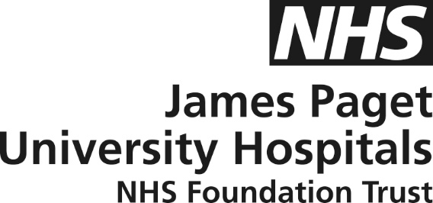

Briefing Sheet following Council of Governors Meeting – March 2021
This summary has been produced following the latest Council of Governors meeting that was held virtually, in public on 10th March 2021. All the papers and a recording of the meeting are available on the Trust website. We do hope that you find the content useful.
- The Trust has faced significant challenges with the number of Covid-positive patients far exceeding those in April 2020 although the situation is improving.
- Patients are at the centre of everything with staff striving to always deliver outstanding care. “Quality walkarounds” have been re-introduced which are unannounced visits with the fresh eyes of Paul Morris, Director of Nursing, to provide more detail on his vision and how quality, safety and the patient experience is developing.
- Communications with patients and family members are continuously reviewed and visiting restrictions, introduced during the pandemic, are being looked at.
- During the bad weather in February, members of the community used their 4x4 vehicles to help staff get to work which was very much appreciated.
- Support for staff wellbeing is a priority, particularly due to the pandemic. A range of initiatives are in place and continue to develop including how staff can be supported during the recovery phase.
- Over 21,000 vaccine doses have been administered from the vaccination hub situated in the Louise Hamilton Centre. The “accessible clinic” specifically adapted by Rebecca Crossley (Specialist nurse) to meet the needs of people with learning difficulties and Autism has received international recognition and has seen a significant take-up.
- The emergency department (ED) children’s area is now open, and work is underway on the next stage of the ED development and the front entrance of both ED and the hospital.
- A mobile Cancer Care Unit will be coming soon which will enable patients to receive Chemotherapy treatment closer to home instead of having to visit the hospital.
- Work is ongoing to see how the numbers of falls with harm and pressure ulcers can be reduced.
- Management is working through the results of the 2020 Staff survey. The results will help identify areas for improvement and allow the celebration of any successes.
- Anna Davidson, Chair, has regular meetings with the Chief Executive and virtual weekly meetings with the Non-Executive Directors. She has also participated in several local, regional, and national virtual meetings.
- Anna also Chairs the new Board Strategic Projects Committee discussing Diagnostic Centres, Electronic Patient Records and early plans for a new hospital.
- Cancer standards have been maintained throughout the pandemic although urgent and emergency care standards have been affected. Performance in these areas should improve with the reduction in the number of Covid-positive patients.
- Unfortunately, the number of patients waiting over 52 weeks for elective surgery has risen but lots of work is being done to ensure no patient suffers clinical harm due to these delays, which will take some considerable time to reduce.
- Asymptomatic testing has been rolled out to all staff, who can now test themselves twice weekly.
- KPMG, the external auditors have been re-appointed by the Council and the contract for the internal auditors, PWC, has been extended by two years by the Trust.
- The national financial “top up” remains and together with the lower activity, hence a lower spend on elective surgery, the forecast is £1m surplus at year end.
If you have any questions, would like clarification on any of the items covered, or have any other matters that you would like to raise, please do not hesitate to contact us. You can do this via the Governors’ email which is governors@jpaget.nhs.uk. We would welcome any feedback and look forward to hearing from you.

