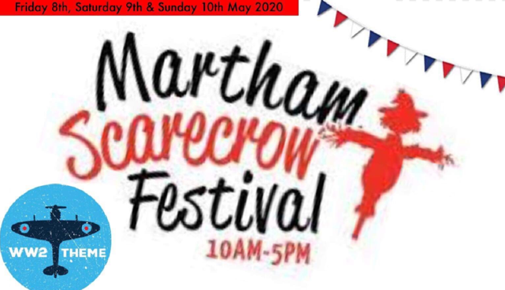
Martham Scarecrow Festival has become a regular fixture in the Village calendar. In previous years, you have been very imaginative with your creations and we look forward to seeing your entries again for this year’s theme which is “World War 2”.
1st Prize = £100 for Best Interpretation of Theme, 2nd Prize = £75 for Most Artistic/Creative & 3rd Prize = £50 for Most Original. Rosettes will also be presented to all winners. Judging will take place on Friday 8th May, Good Luck!
We would like to welcome Garden/Garage Sales for this year. We ask that you kindly donate when booking as this helps towards the cost of advertising which includes your entry. Please note: The organisers of Martham Scarecrow Festival and Martham Parish Council hold no responsibility for any items sold from your property. It is your responsibility to keep your property and saleable items safe.
------------------------------------------------------------------------------------
Full Name: …………………………………………………………………………………………………………………………………………………………
Address: …………………………………………………………………………………………………………………………………………………………….
Telephone: ………………………………………………………. E-mail: …………………………………………………………………………………..

On my Property On the Village Green
SCARECROW
BUNTING
POMPOMS
YARN BOMBING
DECORATED PROPERTY

WW2 Fancy Dress Competition Adult Children
Photographs will be taken and will be published on our Social Media Pages. Please tick the appropriate box below.

Yes, I am happy for my photograph to be published on Martham Scarecrow Festival’s Social Media.
No, I do not want my photograph to be published on Martham Scarecrow Festival’s Social Media.

GARDEN/ GARAGE SALE (Donations welcome with booking)
FRIDAY SATURDAY SUNDAY

Please return Entry Forms by Sunday 19th April 2020.
Forms will not be counted for after this date.

Please return booking form to Chapman’s Butchers or The Flower Gallery.
For more information about this event please contact Laura on 07391844870 or Corrine on 07880507532.
Alternatively, return your Entry Form to: marthamscarecrowfestival@yahoo.com

