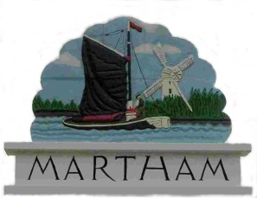
NOTICE OF PARISH COUNCIL FINANCE MEETING
You are hereby summoned to attend the Martham Parish Council Finance Meeting at the Community Centre on:

Wednesday 9th August 2017 at 7.30pm

Finance Committee members are; Cllr Bradford, Gates, Huke, Hurkett and Starkings
Members of the press and public are invited to attend
AGENDA

- ATTENDANCE
To note those present and consider apologies for absence.

- DECLARATIONS OF INTEREST AND DISPENSATIONS
You have a Disclosable Pecuniary Interest in a matter to be discussed if it relates to something on your Register of Interests form. You must declare the interest and leave the room whilst the matter is under discussion.
You have a Personal Interest in a matter to be discussed if it affects:
- Your wellbeing or financial position
- That of your family or close friends
- That of a club or society in which you have a management role
In these instances members must declare a personal interest but can speak and vote on the matter.
Whenever you declare an interest you must say why the interest arises so that it may be included in the minutes.

- MINUTES OF PREVIOUS MEETING
To confirm the accuracy of the minutes of the Parish Council Finance meeting held on 12th April 2017.

- PUBLIC FORUM
To receive public representation on any matter on the agenda.

- MATTERS ARISING – TO RECEIVE UPDATES
5.1 Lloyds Bank Account
5.2 Gym update.

- BUDGET 2017/18
To review budget and cost code allocation to date.

- GRANTS 2018/19
To consider inviting local organisations to apply for grants.

- CONCURRENT FUNCTIONS/COUNCIL TAX SUPPORT GRANT.
Update from Clerk following Parish Liaison Meeting.

- ITEMS FOR NEXT AGENDA

Published 3rd August 2017

Sarah Hunt

Clerk and Responsible Financial Officer

